FATIMA JINNAH WOMEN UNIVERSITY



Submitted To:

Sir Majid Shafique

Submitted By:

Amna Javed

Reg no.

23-BCS-009

Program:

BS Computer Science 5B

Course Title:

OS

Phase 2 – Server Setup & Configuration Checklist

1. FTP Server (vsftpd)
Config file screenshot:
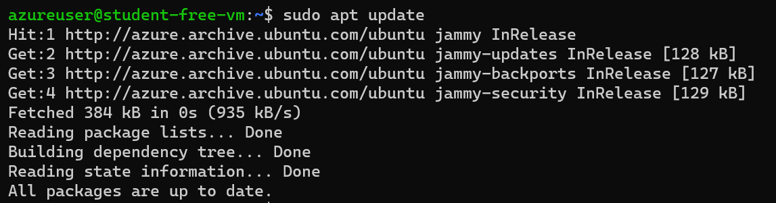
Verification commands & screenshot:
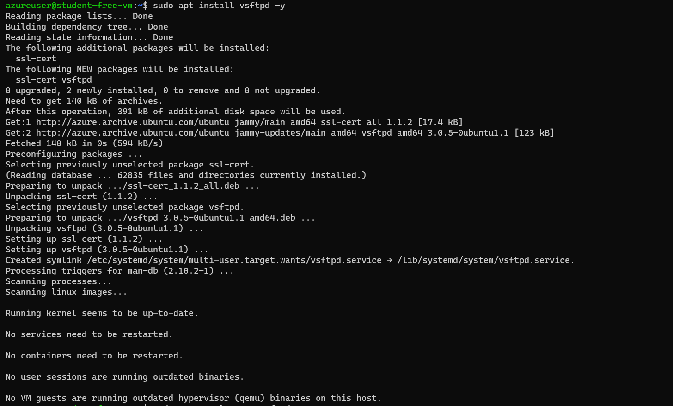
From VM2
ftp 10.0.0.4
login as ftpuser
password ftp123
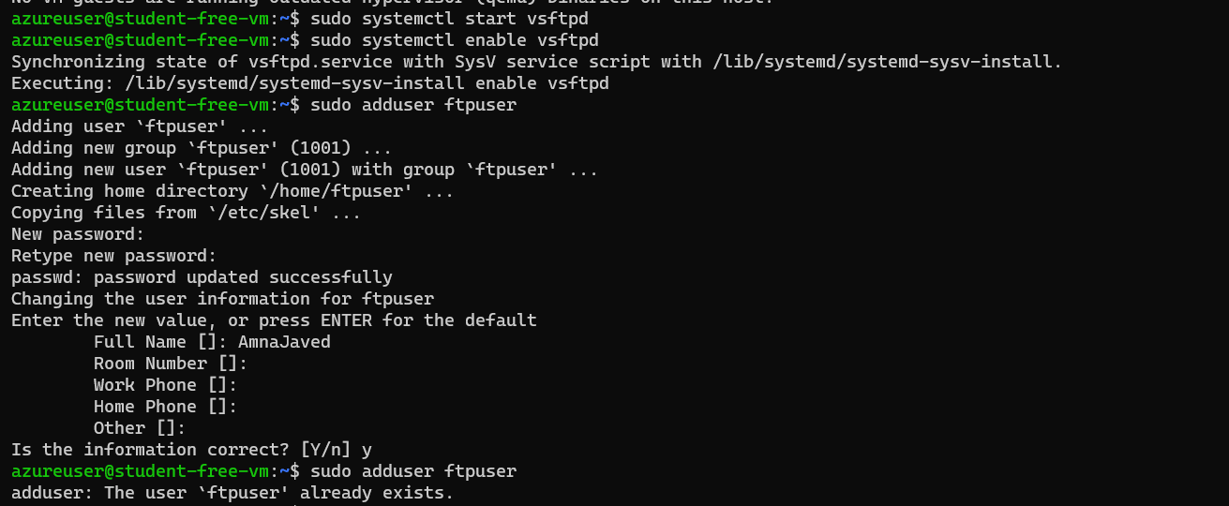
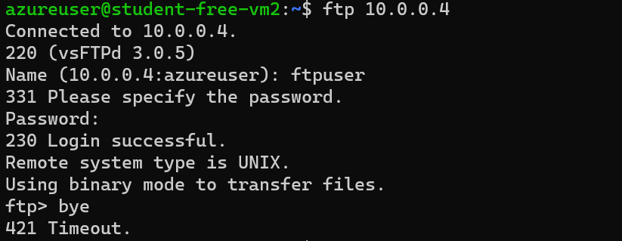
  - Figure 1: FTP login success

230 login successful

2. Web Server (Apache2)
Config file screenshot (optional if default page is used):
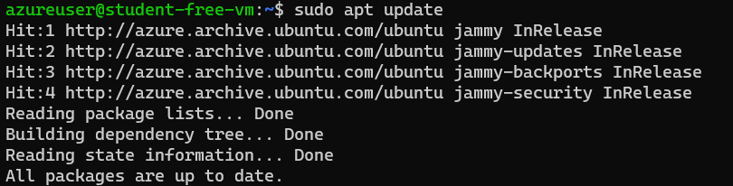

sudo apt install apache2 -y

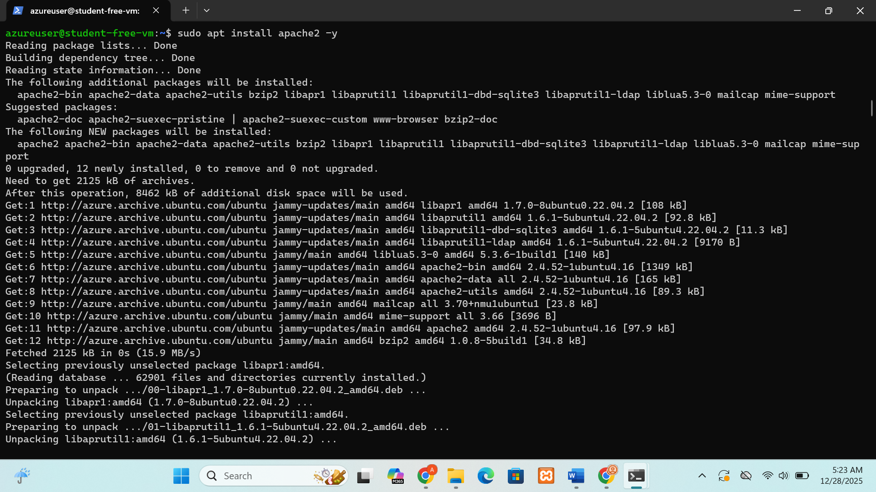
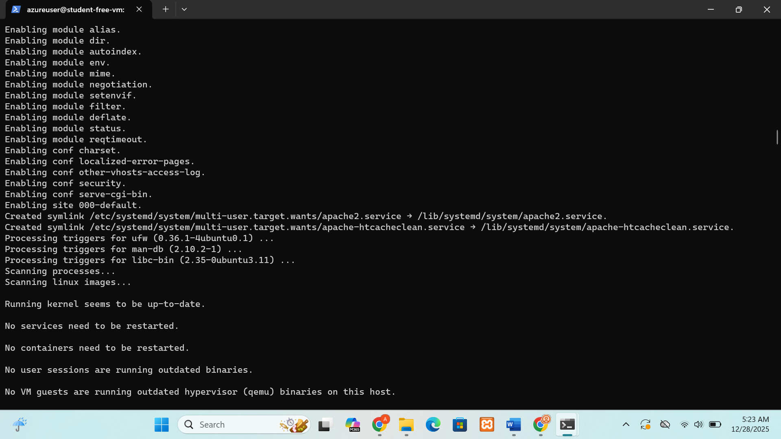

Verification commands & screenshot:
From VM2
curl http://10.0.0.4 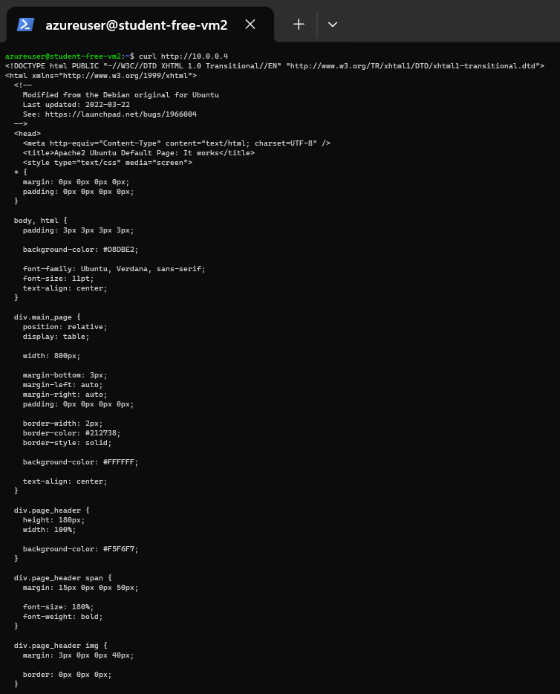
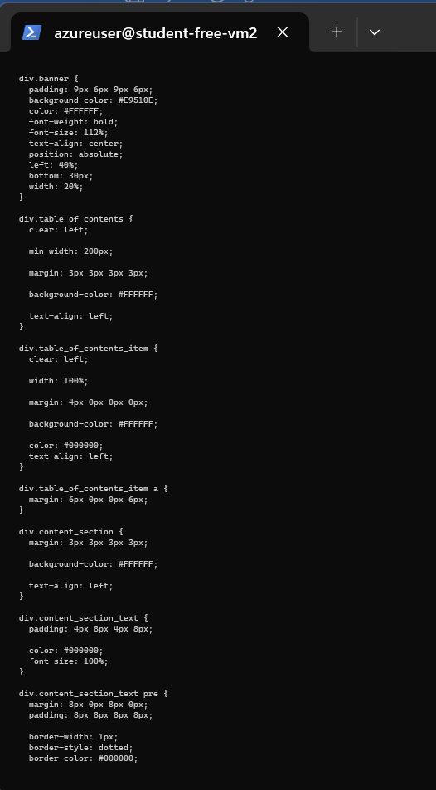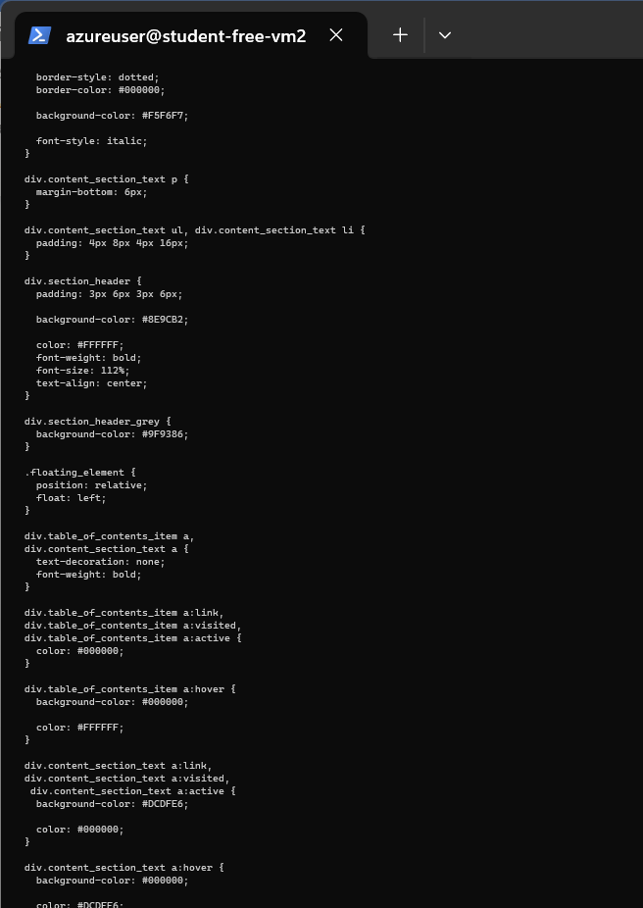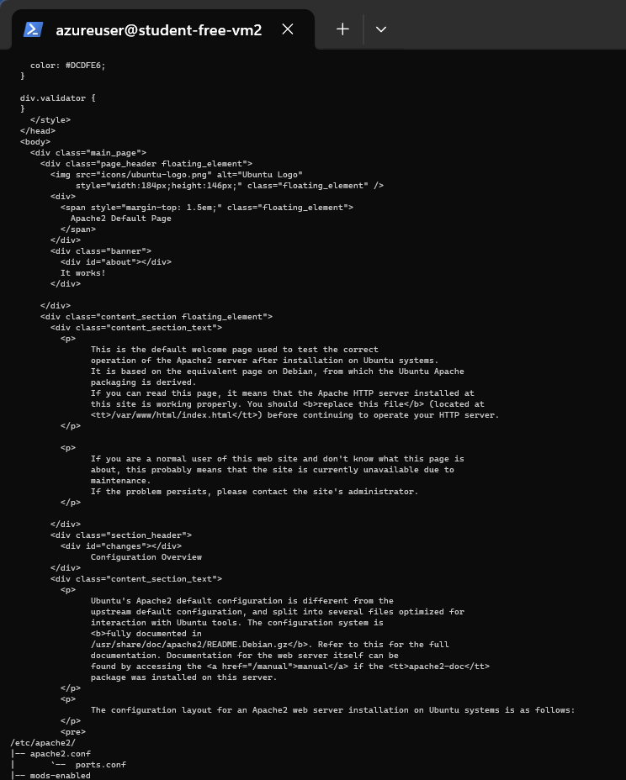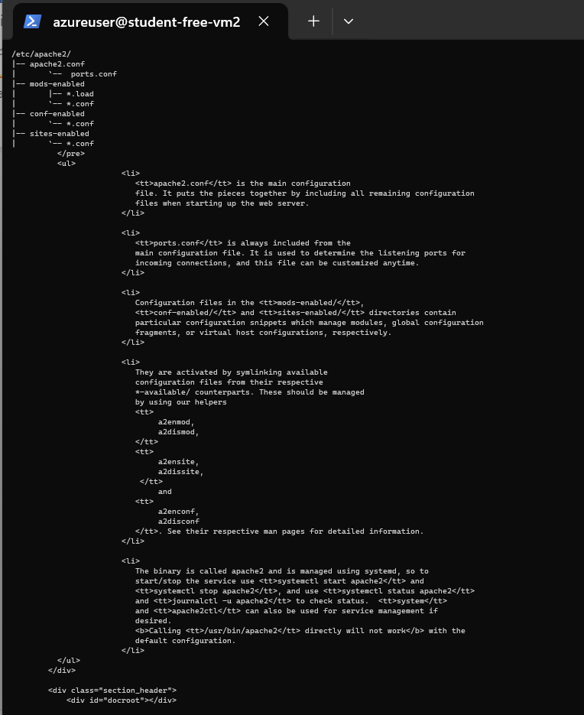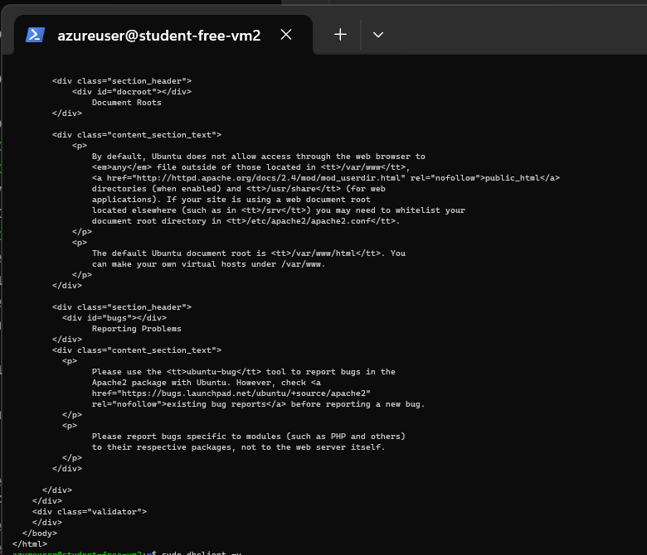
  - Figure 2: Apache2 default page

3. DNS Server (BIND9)
Config file screenshot:

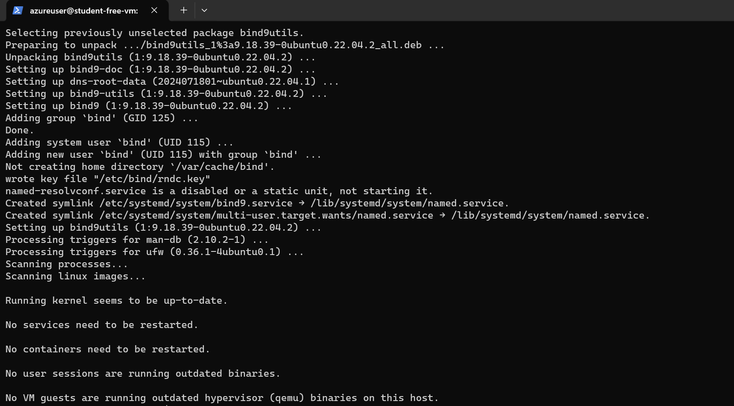
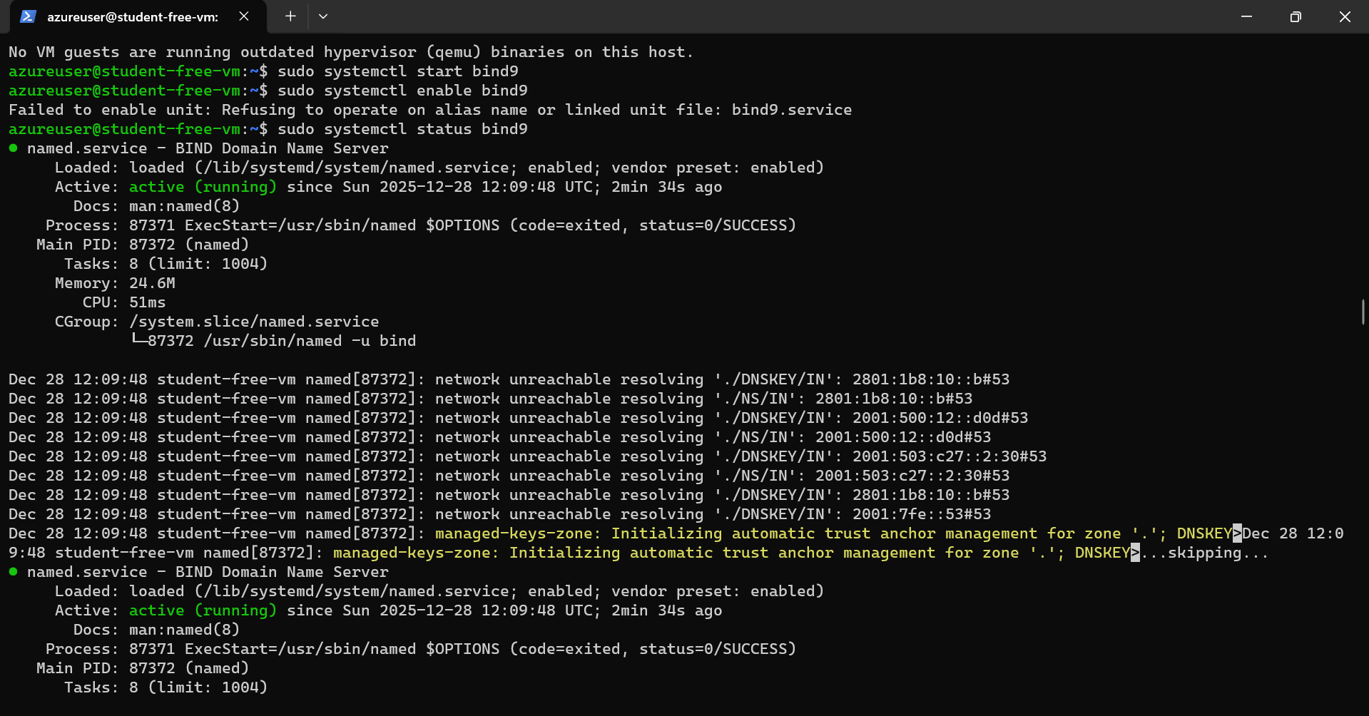
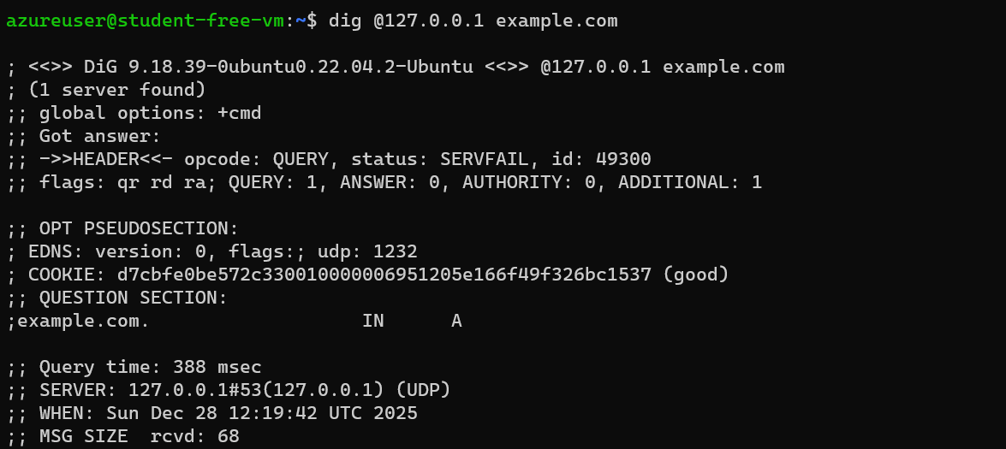
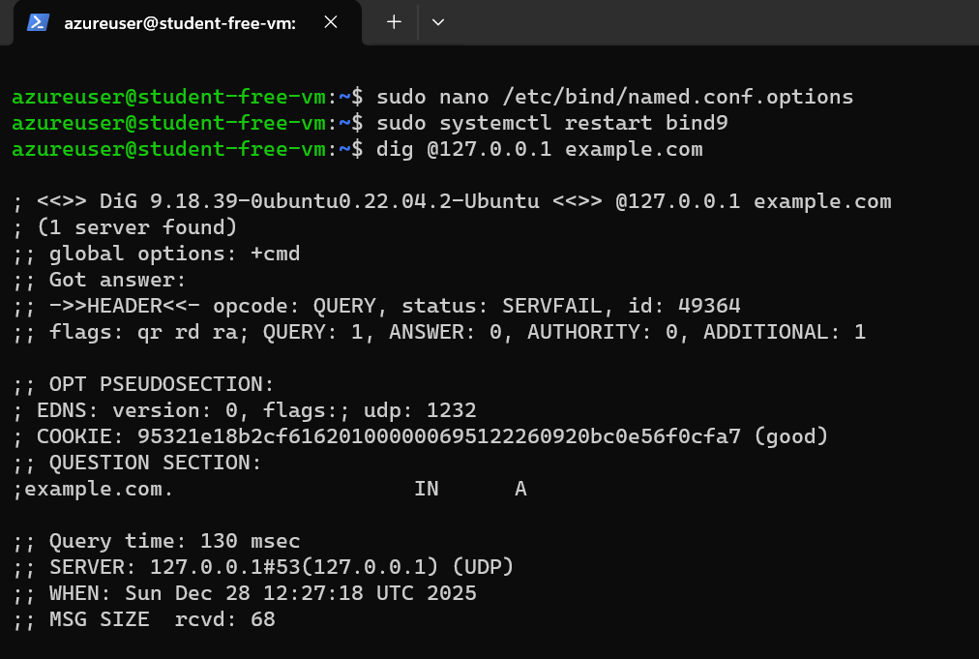
sudo nano /etc/bind/named.conf.options
Verification commands & screenshot:
dig @127.0.0.1 example.com
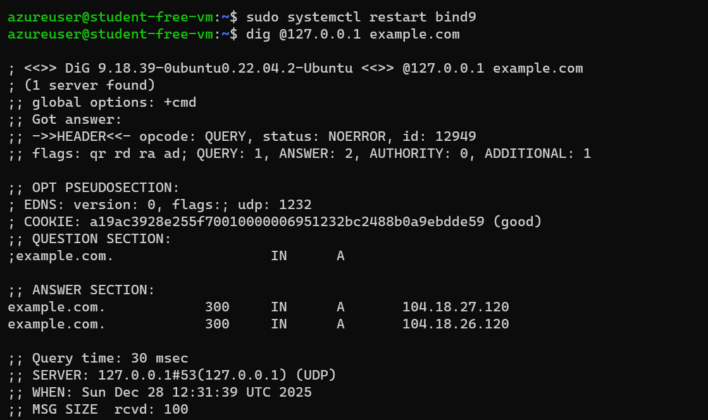
  - Figure 3: DNS dig result

4. DHCP Server (isc-dhcp-server)
Config file screenshot:
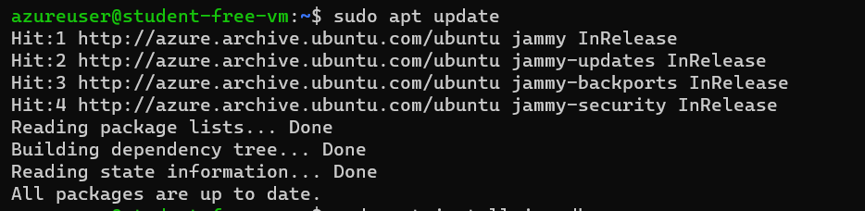
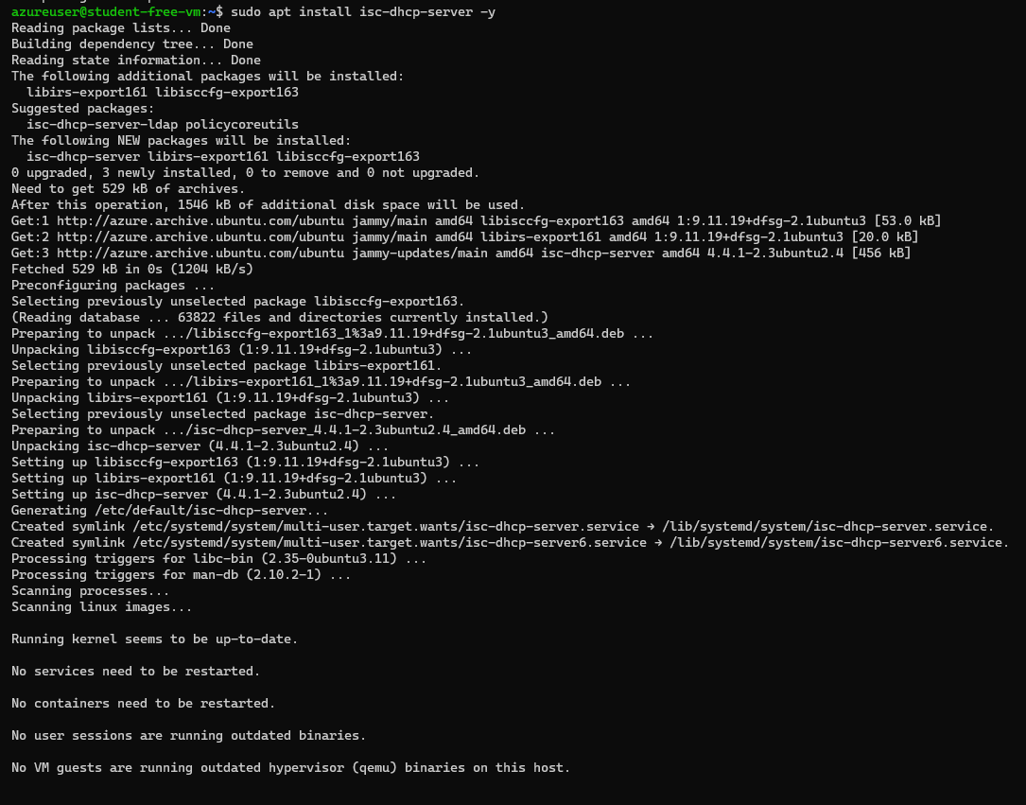

- Include: subnet, range, domain-name, DNS servers, lease times. Example:
subnet 10.0.0.0 netmask 255.255.255.0 {
range 10.0.0.10 10.0.0.100;
option routers 10.0.0.4;
option domain-name-servers 10.0.0.4;
}
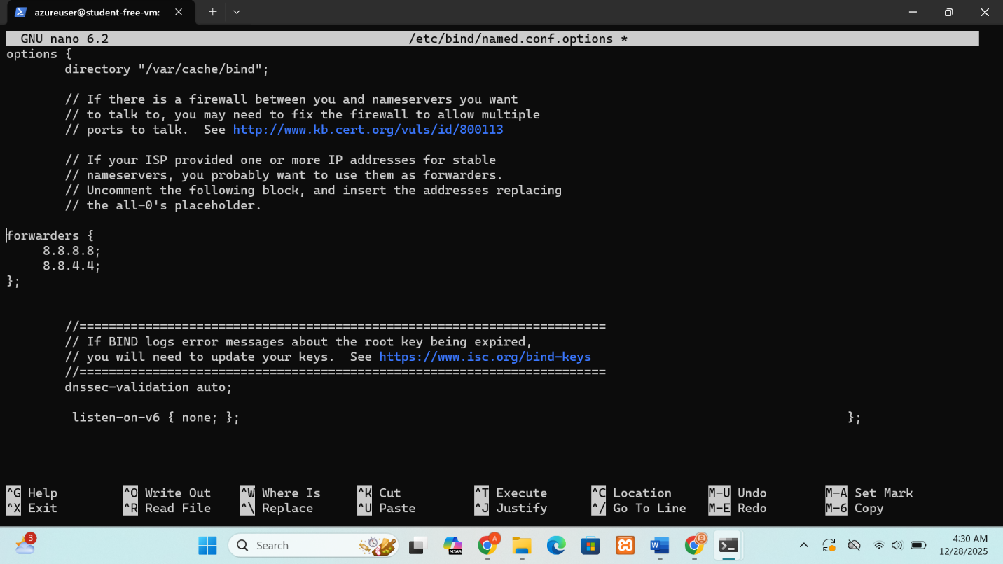
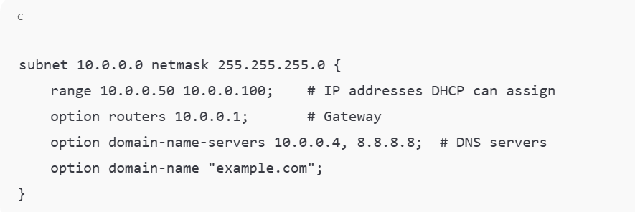
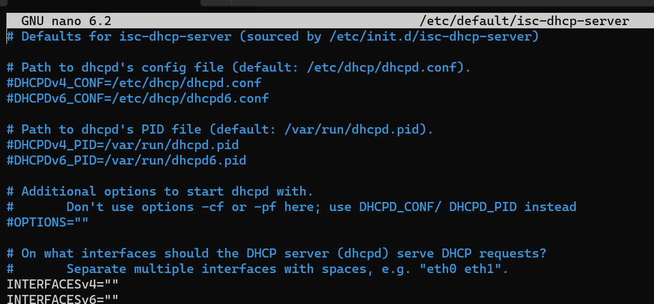
Verification commands & screenshot:
# From VM2
sudo dhclient -v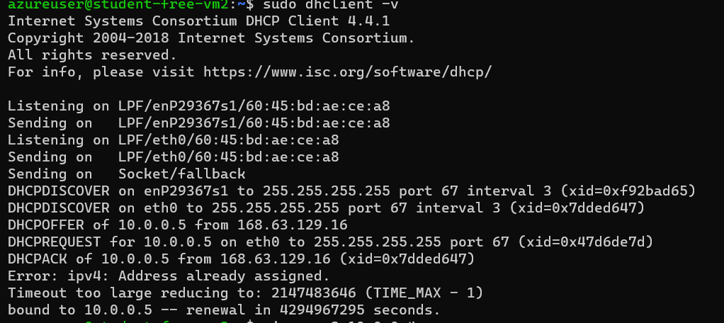
  - Figure 4: DHCP IP assigned

5. Proxy Server (Squid)
Config file screenshot:
sudo nano /etc/squid/squid.conf
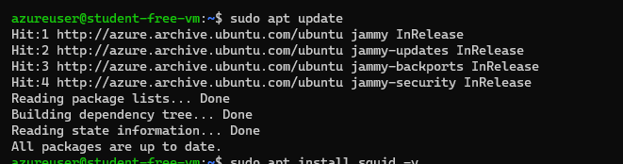
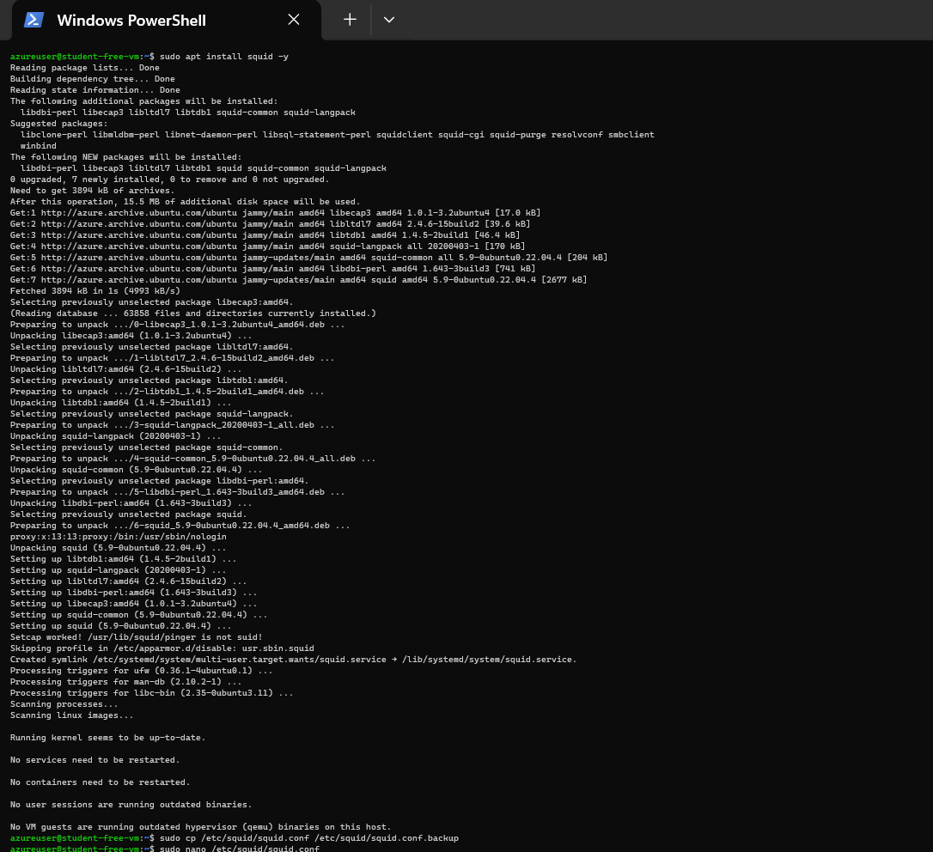

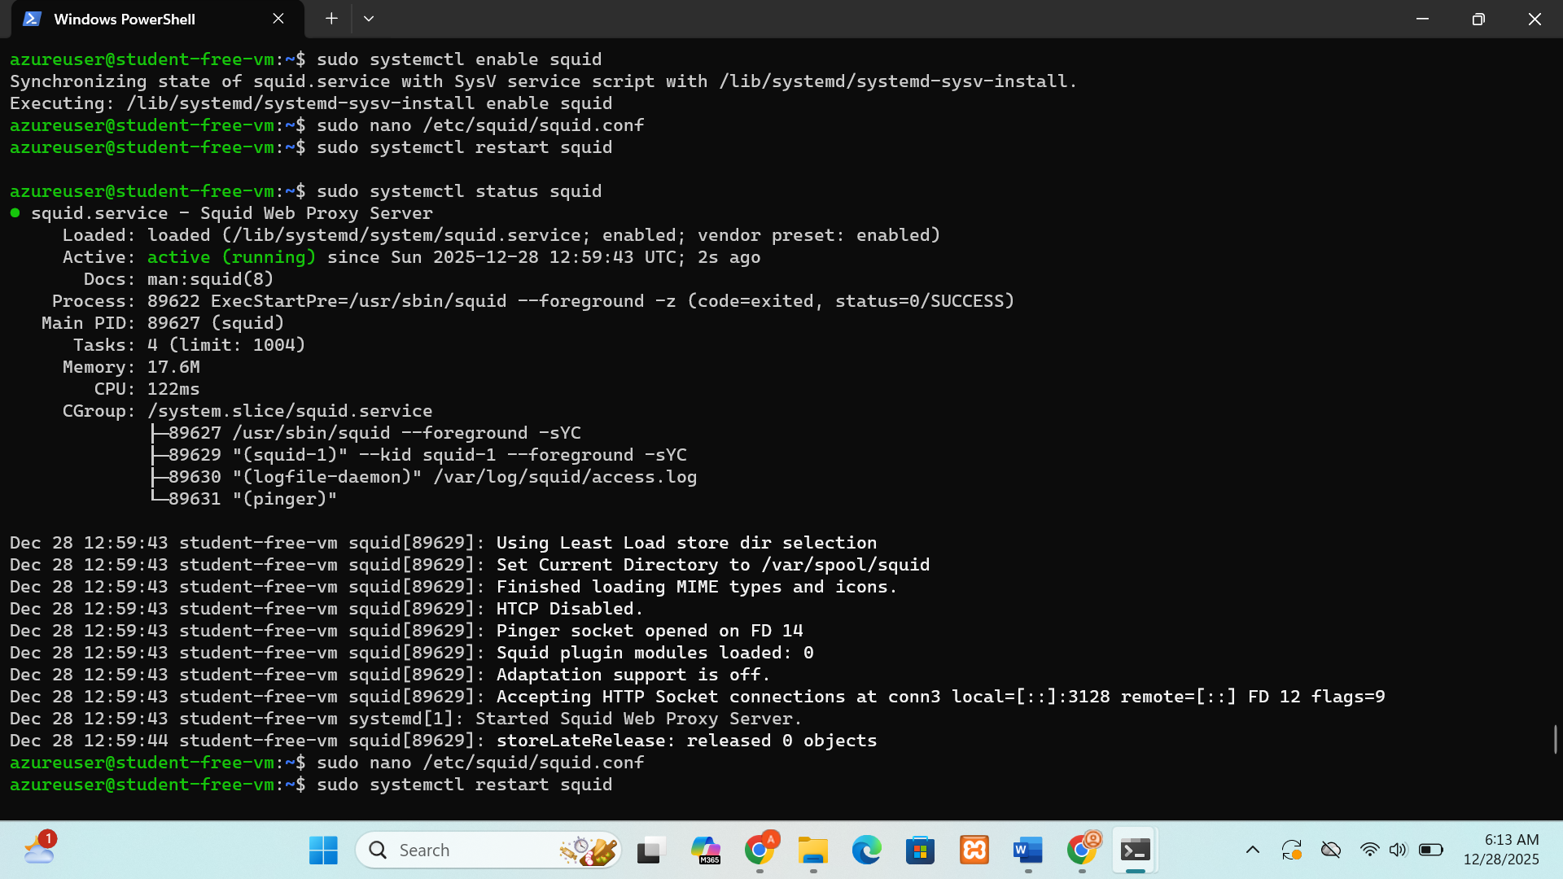
- Include
http_port 3128
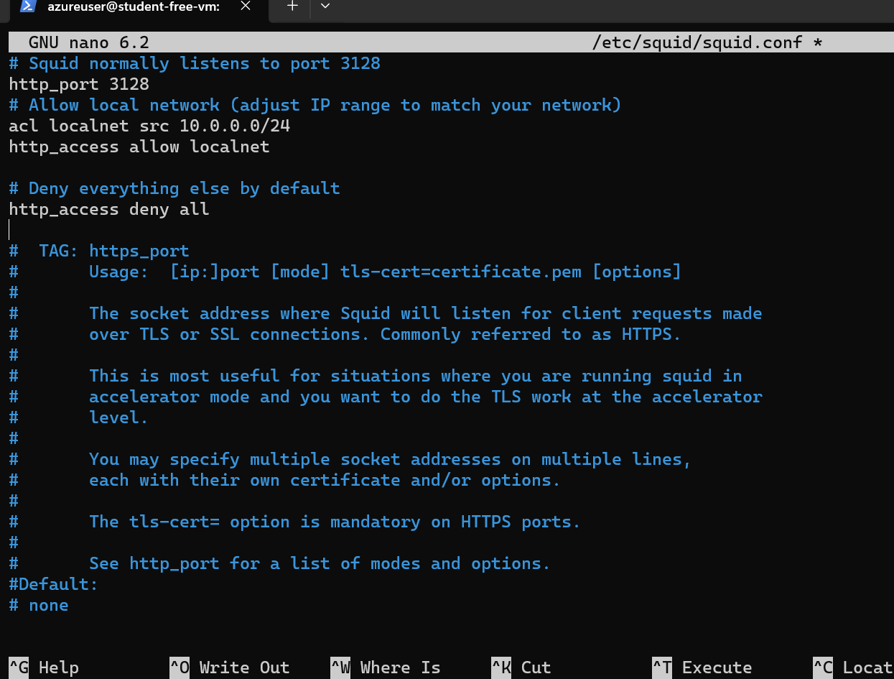
Verification commands & screenshot:
# From VM2
curl -x http://10.0.0.4:3128 http://example.com
  - Figure 5: Proxy server output
Screenshot should show the Example Domain webpage loading successfully through the proxy.
- 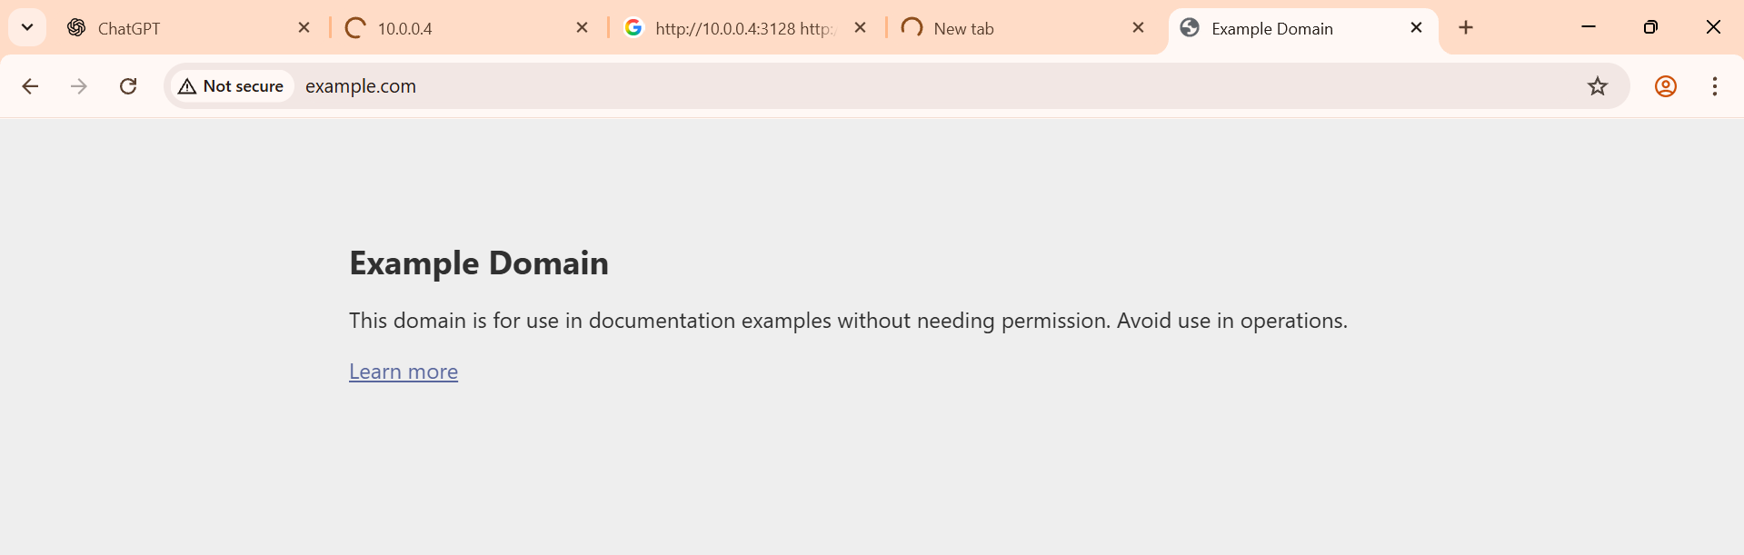

6. Server Status Checks (Optional for each server)
You can also include a screenshot for each service showing it is running:
sudo systemctl status vsftpd

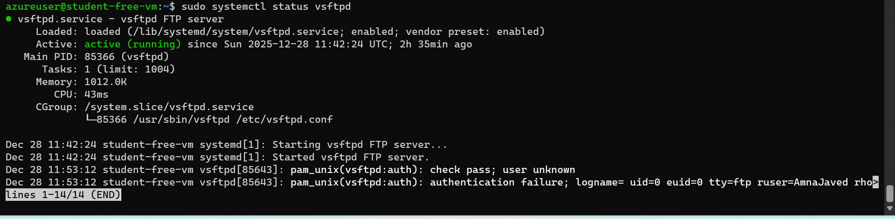
sudo systemctl status apache2

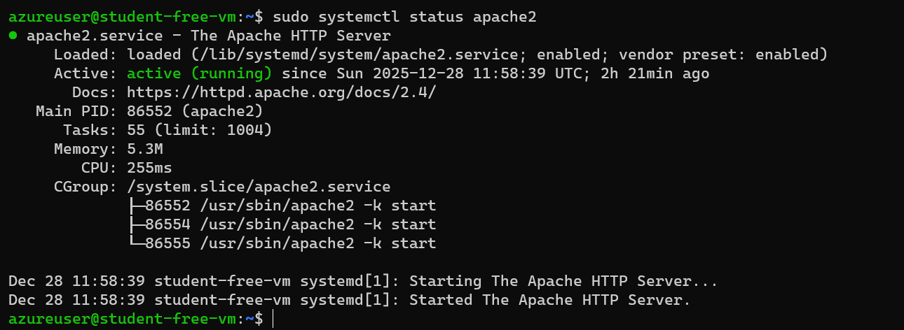

sudo systemctl status bind9

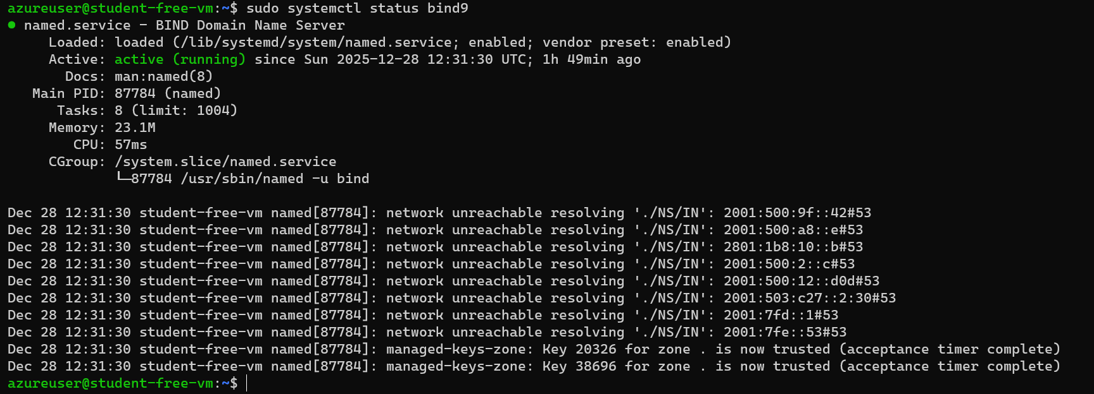

sudo systemctl status isc-dhcp-server

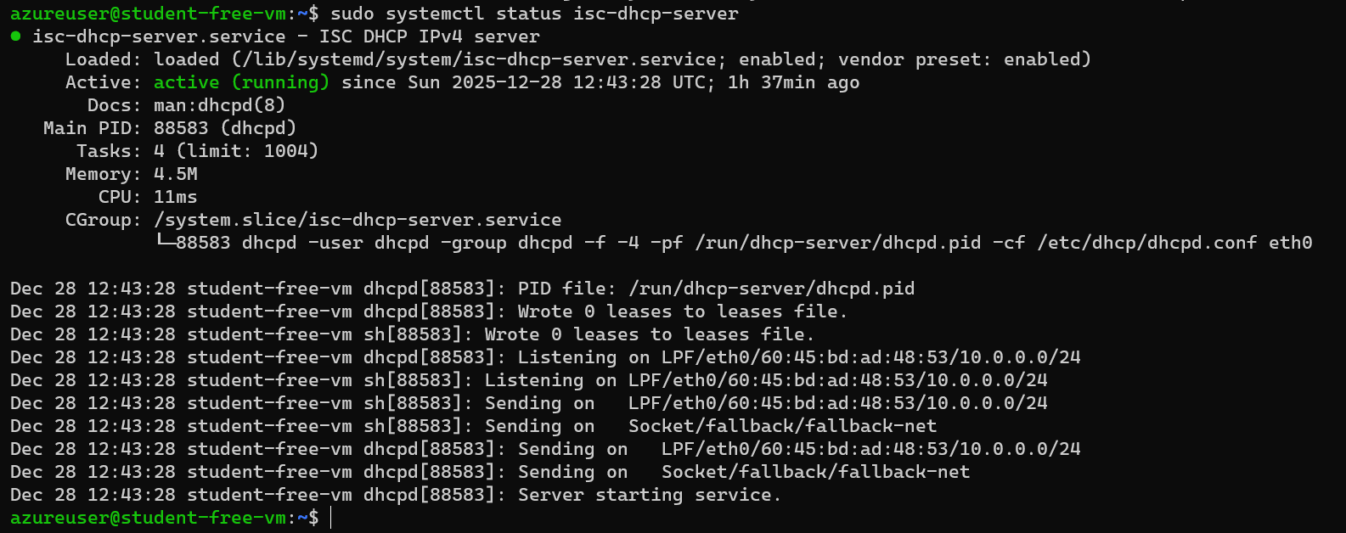

sudo systemctl status squid

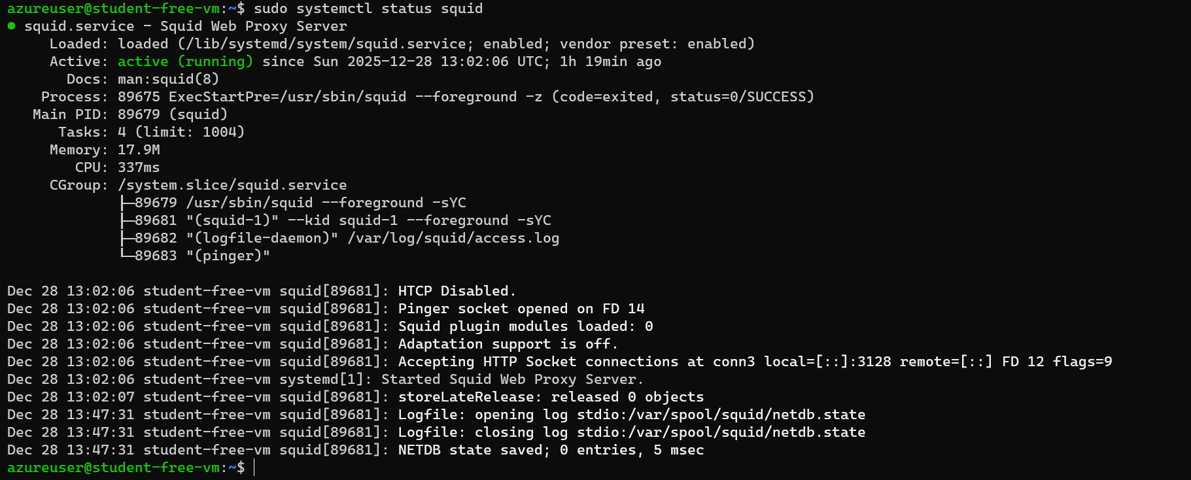
- All are Active: active (running) is visible.

7. Final Remarks Section
- All Phase 2 servers (FTP, Web, DNS, DHCP, Proxy) have been installed and configured.
- VM2 successfully connects to all services.
- DHCP assigns IPs correctly, DNS resolves names, Apache serves web pages, FTP login works, and Squid proxy serves web pages.
  - Figure 1: FTP login success
  - Figure 2: Apache2 default page
  - Figure 3: DNS dig result
  - Figure 4: DHCP IP assigned
  - Figure 5: Proxy server output

